***DATA DICTIONARY***

SUMIT RANJAN – 16103061

ARCHIT SINGAL – 16103063

ISHAAN KANWAR – 16103064

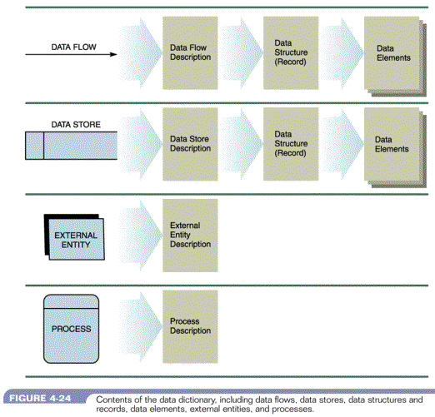

***PROCESS***

|  |  |
| --- | --- |
| Process Name | 1.0 Registration Subsystem |
| Process Description | This process adds the new users to the database |
| Inbound | Registration Request, Acknowledgement |
| Outbound | Insert Buyer Details, Insert Seller Details |
|  |  |
| Process Name | 2.0 Login Subsystem |
| Process Description | Already registered users access website through this |
| Inbound | Login Details |
| Outbound | Acknowledgement |
|  |  |
| Process Name | 3.0 Redirection Subsystem |
| Process Description | Makes sure that the visitor is directed to the correct web page |
| Inbound | Redirect from Login |
| Outbound |  |
|  |  |
| Process Name | 4.0 Purchase Subsystem |
| Process Description | All the details regarding the object to be purchased are available here |
| Inbound | Fetch Seller Details, Fetch Product Details, Purchase Request, Search |
| Outbound | Seller Details |
|  |  |
| Process Name | 5.0 Seller Subsystem |
| Process Description | All the details regarding the object to be sold are available here |
| Inbound | Insert Product, Fetch Product Details, Redirect to Sell |
| Outbound | Update Product, Acknowledgement |

***DATA STORE***

|  |  |
| --- | --- |
| Data Store Name | Buyer Detail Database |
| Description | This database contains all the details about the buyer |
| Data Elements | Username |
|  | Name |
|  | Contact |
|  | Email Id |
|  |  |
| Data Store Name | Seller Details Database |
| Description | This database contains all the details about the seller |
| Data Elements | Username |
|  | Name |
|  | Contact |
|  | Email Id |
|  |  |
| Data Store Name | Product Details Database |
| Description | This database contains the details of the product listed for sale |
| Data Elements | Name of book |
|  | Name of Author |
|  | Cost |
|  | Contact of seller |

***DATA FLOW***

|  |  |
| --- | --- |
| Data Flow Name | Registration Request |
| Description | User requests for registering on to system |
| Source | New User |
| Destination | 1.0 Registration Subsystem |
| Data Contents | username, Mobile Number, password |
|  |  |
| Data Flow Name | Acknowledgement |
| Description | Verifies the details |
| Source | Seller database and Buyer Database |
| Destination | 1.0 Registration Subsystem |
| Data Contents | Username, Password, Mobile Number |
|  |  |
| Data Flow Name | Insert Seller Details |
| Description | Insert the details in database if it is not present in database |
| Source | 1.0 Registration Subsystem |
| Destination | Seller database |
| Data Contents | Username, Password, Mobile Number |
|  |  |
| Data Flow Name | Insert Buyer Details |
| Description | Insert the details in database if it is not present in database |
| Source | 1.0 Registration Subsystem |
| Destination | Buyer Database |
| Data Contents | Username, Password, Mobile Number |
|  |  |
| Data Flow Name | Update Product |
| Description | Updates the product details in product details database |
| Source | 5.0 Seller Subsystem |
| Destination | Product details Database |
| Data Contents | Books Name, Price |
|  |  |
| Data Flow Name | Insert Product |
| Description | Inserting the details of product |
| Source | Seller |
| Destination | 5.0 Seller Subsystem |
| Data Contents | Book Name, Price |
|  |  |
| Data Flow Name | Fetch Product Details |
| Description | Fetching the details from database inorder to change something |
| Source | Product details Database |
| Destination | 5.0 Seller Subsystem |
| Data Contents | Book Name, Price |
|  |  |
| Data Flow Name | Login Details |
| Description | Seller and buyer sends their respective details to login subsystem |
| Source | Seller and buyer |
| Destination | Login Subsystem |
| Data Contents | Username, Password |
|  |  |
| Data Flow Name | Purchase Request |
| Description | Request to purchase a books |
| Source | Buyer |
| Destination | 4.0 Purchase Subsystem |
| Data Contents | Price Details, Request Contact of seller |
|  |  |
| Data Flow Name | Search Product |
| Description | Requests for a particular product |
| Source | Buyer |
| Destination | 4.0 Purchase Subsystem |
| Data Contents | Book Name, Author |
|  |  |
| Data Flow Name | Fetch details |
| Description | System fetches the details of requested product |
| Source | 4.0 Purchase Subsystem |
| Destination | Product Details |
| Data Contents | Book Name, Author name |
|  |  |
| Data Flow Name | Fetch Seller Details |
| Description | Fetches the seller details corresponding to requested book |
| Source | Seller Details Database |
| Destination | 4.0 Purchase Subsystem |
| Data Contents | Name, Contact number, Email ID |
|  |  |
| Data Flow Name | Seller Details |
| Description | Gives the seller details to Buyer |
| Source | 4.0 Purchase Subsystem |
| Destination | Buyer |
| Data Contents | Name, Contact Number |
|  |  |
| Data Flow Name | Show Product Details |
| Description | Gives the details of requested product to Buyer |
| Source | 4.0 Purchase Subsystem |
| Destination | Buyer |
| Data Contents | Book Name, Author Name, Price |
|  |  |
| Data Flow Name | Redirect |
| Description | Redirects the control to redirection subsystem to login subsystem |
| Source | 2.0 Login Subsystem |
| Destination | 3.0 Redirection Subsystem |